Low Level Design
On
Marketing Content Generator
Institution Name: Medicaps University – Datagami Skill Based Course

Student Name(s) & Enrolment Number(s):
BY
Sr no | Student Name | Enrolment Number
1 | SHRADDHA THAKUR | EN22CS301924
2 | AADARSH BHAWSAR | EN23CS3T1012
3 | SAMYAK LALAN | EN22CS301858
4 | ANIL KUMAR SHAH | EN23CS3L1003
5 | BADAL PATIDAR | EN22EE301005

Group Name: Group 11D8
Project Number: GAI-46
Industry Mentor Name: Aashruti Shah
University Mentor Name: Divya Kumawat
Academic Year:2026

Table of Contents
1. Introduction.
  - Scope of the document.
1.2. Intended Audience
1.3. System overview.
2.System Design.
2.1. Application Design
2.2. Process Flow.
2.3. Information Flow.
2.4. Components Design
2.5. Key Design Considerations
3.References

1. Introduction

Scope of the Document
This document describes the design and implementation of a Marketing Content Generator using Generative AI. The system leverages Large Language Models (LLMs) and Vector Databases to generate high-quality marketing content such as ad copies, promotional text, and campaign material.
The goal of this project is to automate content creation for marketing professionals while ensuring consistency, creativity, and efficiency.

Intended Audience
This document is intended for:
- Developers working on AI-based applications
- Data scientists and ML engineers
- Marketing professionals using the tool
- Project managers and stakeholders

System Overview
The system consists of the following components:
- Frontend Interface – User inputs topic/prompts
- Backend (Python) – Handles logic and API calls
- LLM API – Generates content
- Vector Database – Stores embeddings for context
- Prompt Engine – Optimizes prompts for output quality

2. System Design

2.1. Application Design
The application follows a modular architecture:
- User Input Module – Accepts topic/keywords
- Prompt Engineering Module – Enhances input prompts
- LLM Processing Module – Generates content
- Vector DB Module – Retrieves relevant context
- Output Module – Formats final content

2.2. Process Flow
The working process is as follows:
- User enters a topic (e.g., "Fitness App Promotion")
- Prompt is enhanced using prompt engineering
- Query is sent to LLM API
- Vector DB retrieves relevant context (if needed)
- LLM generates marketing content
- Output is formatted and displayed to user

2.3. Information Flow
• User Input → Backend (Python)
• Backend → Prompt Engine
• Prompt Engine → LLM API
• LLM ↔ Vector Database
• Generated Content → User Interface

Flow Diagrams

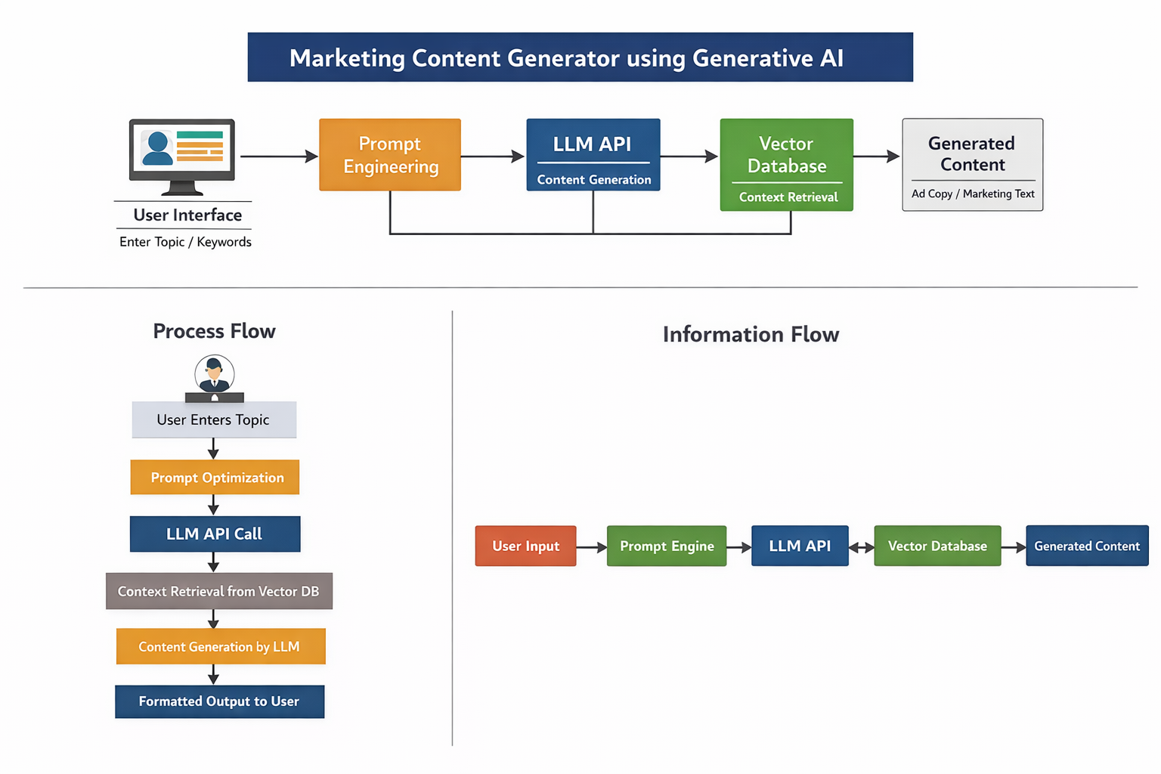

2.4. Components Design
1. Frontend
- Accepts user input
- Displays generated content
2. Backend (Python)
- Core logic implementation
- Handles API requests
3. LLM API (Open API)
- Generates text content
- Uses advanced NLP models
4. Vector Database
- Stores embeddings
- Provides contextual relevance
5. Prompt Engineering System
- Improves input quality
- Ensures structured output

2.5. Key Design Considerations
1. Security
- Secure API keys
- Controlled access to system
2. Performance
- Fast response using optimized prompts
- Efficient API calls
3. Scalability
- Can handle multiple users
- Extendable for different industries
4. Automation
- Reduces manual writing effort
- Speeds up marketing workflows
5. Accuracy & Consistency
- Maintains tone and structure
- Uses predefined prompt templates

6. Advantages of the System
- Saves time for marketers
- Generates professional-quality content
- Reduces human effort
- Ensures consistency in branding
- Scalable and customizable
7. Technologies Used
- Python – Backend development
- LLM API(GPT-4o) – Content generation
- Vector Database – Context retrieval
- Prompt Engineering – Output optimization
3. References
- Generative AI Documentation
- LLM API Documentation
- Python Documentation
- Vector Database Documentation

Conclusion
The Marketing Content Generator successfully demonstrates the use of Generative AI in automating marketing workflows. By integrating LLMs, prompt engineering, and vector databases, the system produces high-quality, consistent, and professional content with minimal human effort.

